# LED328P programming instructions

1. Add a development board (ArduinoIDE comes with Arduino AVR Boards by default, you can skip this step)

Tools->board:"xxx"->Boards Manager, search for "Arduino AVR Boards", click Install to add the development board

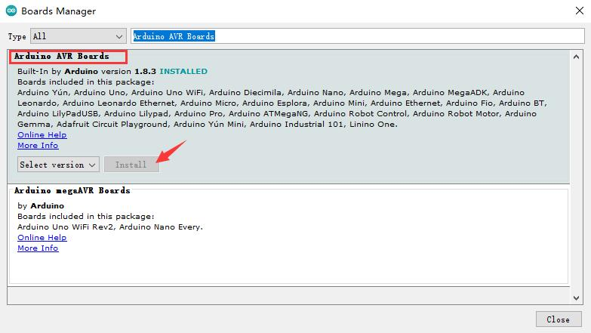

2.Add library

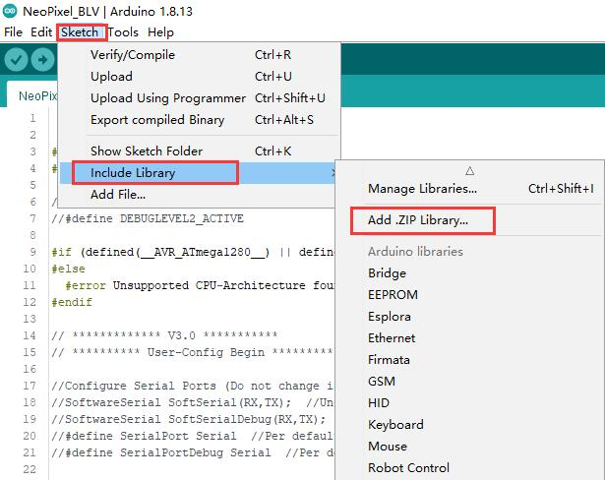

Add“Adafruit\_NeoPixel-master.zip”（<https://github.com/adafruit/Adafruit_NeoPixel>）

1. Upload firmware

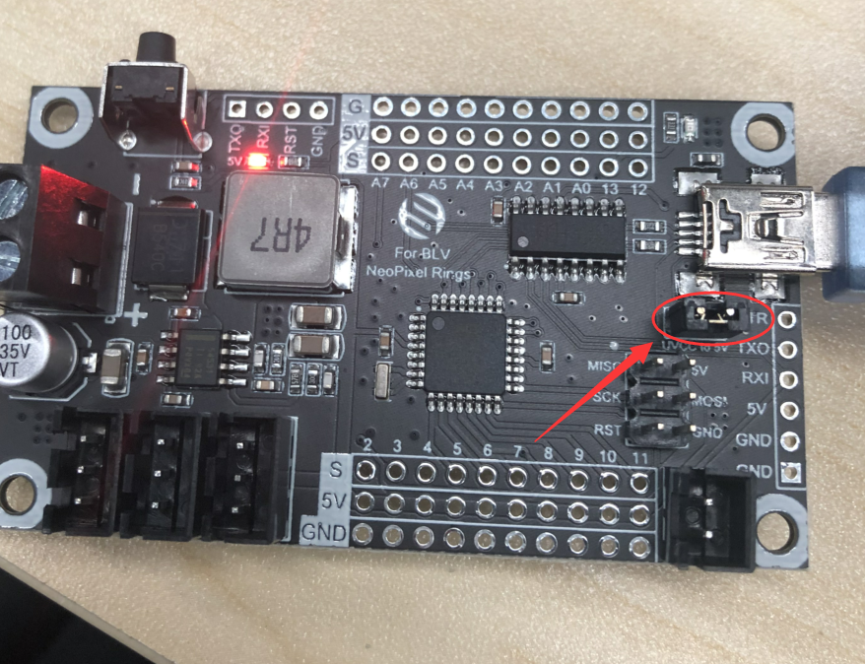

As shown in the figure above, you need to plug in the jumper cap when uploading the firmware, and you need to unplug it when you are done, plug in the USB

Open project file“[NeoPixel\_BLV.ino](https://github.com/FYSETC/FYSETC-BLV-MGN-CUBE/blob/main/Firmware/NeoPixel_Ring light/NeoPixel_BLV.ino" \o "NeoPixel_BLV.ino)”

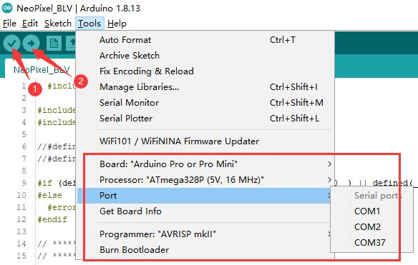

Select "Arduino Pro or Pro Mini" for development board;

The processor selects "Atmega328P (5V, 16MHz)";

Choose the correct COM;

Click 1 to compile the firmware, and then click 2 to upload the firmware;

Wait for the firmware upload to complete.